|  |
| --- |
| EPAM Systems, RD Dep. |
| MTN.BI.08 Load and Transformation |

|  |  |  |  |  |  |
| --- | --- | --- | --- | --- | --- |
| REVISION HISTORY | | | | | |
| Ver. | Description of Change | Author | Date | Approved | |
| Name | Effective Date |
| 1.0 | Initial status | Hanna Hul | 12-JAN-2012 |  |  |

Contents

1. Data Modelling Task 3

1.1. Detail your diagrams for 3NF and Star layers. 3

1.2. Create visual and textual description of layers of your data warehouse. 3

2. Data Vault 3

# Data Modelling Task

## Detail your diagrams for 3NF and Star/snowflake layers.

Reminder:

* You need to have at least 5 dimensions.
* You need to use at least 2 type SCD2 attributes in different dimensions.

Create visual and textual description of layers of your data warehouse.

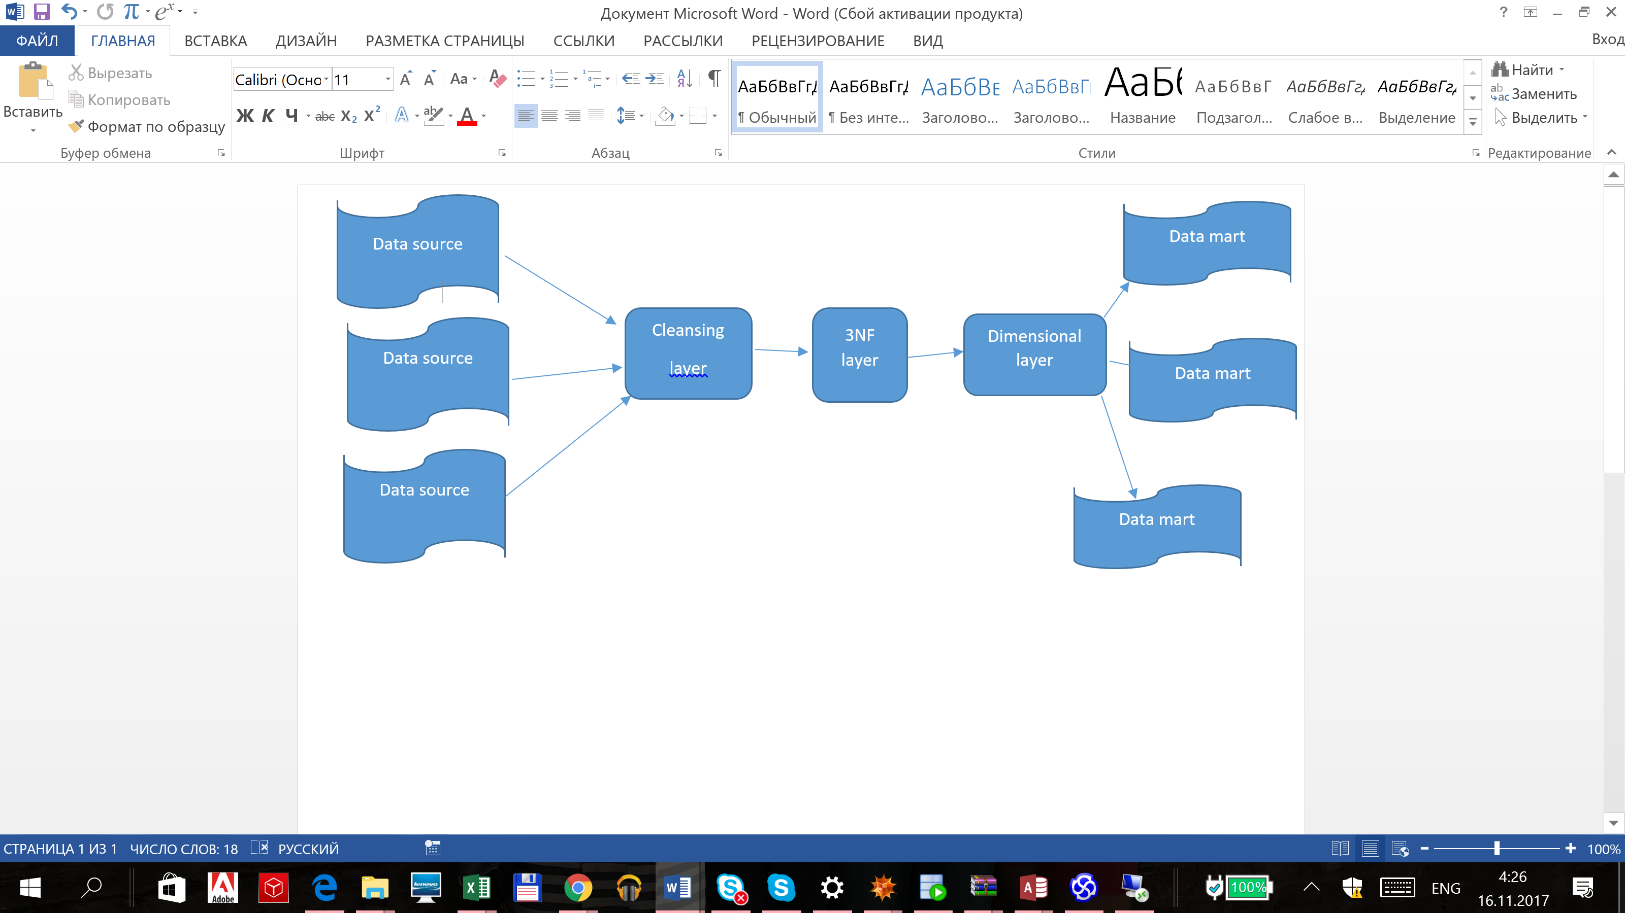

* Image (PowerPoint or whatever tool do you prefer) of your data warehouse layers.

# Data Vault

* Get back to the task 5 from and refactor sample business schema into the Data Vault model.